

Practices for Secure Software Report

Table of Contents
Document Revision History 3
Client 3
Instructions 3
Developer 4
1. Algorithm Cipher 4
2. Certificate Generation 4
3. Deploy Cipher 4
4. Secure Communications 4
5. Secondary Testing 4
6. Functional Testing 4
7. Summary 4
8. Industry Standard Best Practices 4

Document Revision History

Version | Date | Author | Comments
1.0 | 6/20/2026 | Malek Ewais | Initial Submission

Client



Instructions

Submit this completed practices for secure software report. Replace the bracketed text with the relevant information. You must document your process for writing secure communications and refactoring code that complies with software security testing protocols.

- Respond to the steps outlined below and include your findings.
- Respond using your own words. You may also choose to include images or supporting materials. If you include them, make certain to insert them in all the relevant locations in the document.
- Refer to the Project Two Guidelines and Rubric for more detailed instructions about each section of the template.

Developer
Malek Ewais

Algorithm Cipher

To improve the security of the Artemis Financial application, I recommend using the Advanced Encryption Standard (AES) with a 256-bit key (AES-256) as the primary encryption algorithm. AES is a symmetric encryption algorithm that is widely used by government agencies, financial institutions, and private organizations to protect sensitive information. It is widely considered to be one of the most secure encryption standards available. It is approved by the U.S. government, and is used to protect classified information.

AES-256 uses a 256-bit key length, which provides a very large number of possible key combinations and makes brute-force attacks computationally impractical. Cryptographic hash functions are used for data verification integrity. In this project, the SHA-256 hashing algorithm was implemented to generate a checksum value for a unique data string. For this project, the SHA-256 algorithm was implemented to generate checksum value for a unique data string. SHA-256 produces a 256-bit hash value that can be used to verify that data has not been modified during transmission. AES-256 and SHA-256 together provide confidentially and integrity for secure communications.

The same key is used for both encryption and decryption. That is what the symmetric AES encryption algorithm is. This differs from asymmetric encryption, which uses a public key and a private key. Asymmetric encryption is commonly used to exchange or protect keys, while symmetric encryption is used for the actual data because it is more efficient. Anther important component to this, is the Random number generation. It is so, because it helps create encryption keys that are secure. As well as initialization vectors, and other security-related values that are difficult to predict by potential attackers.

Early encryption methods relied on simple substitution ciphers that could be broken relatively easily. The Data Encryption Standard (DES) was widely used once, but over time it became vulnerable due to its shorter key length. Triple DES improved security but was later replaced by AES, which became the industry standard in by the earlier 2000s. Today, AES-256 remains one of the most trusted encryption algorithms available and is commonly used alongside SHA-256 and TLS protocols to secure sensitive information and communications.

Certificate Generation
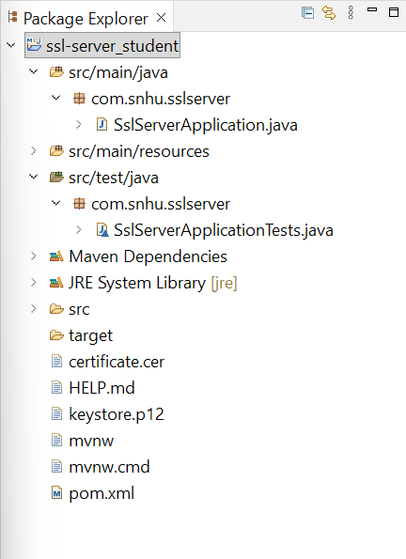

A self-signed certificate was generated using Java Keytool and exported as a CER file. The certificate was used to support secure HTTPS communications within the Artemis Financial application.

Deploy Cipher

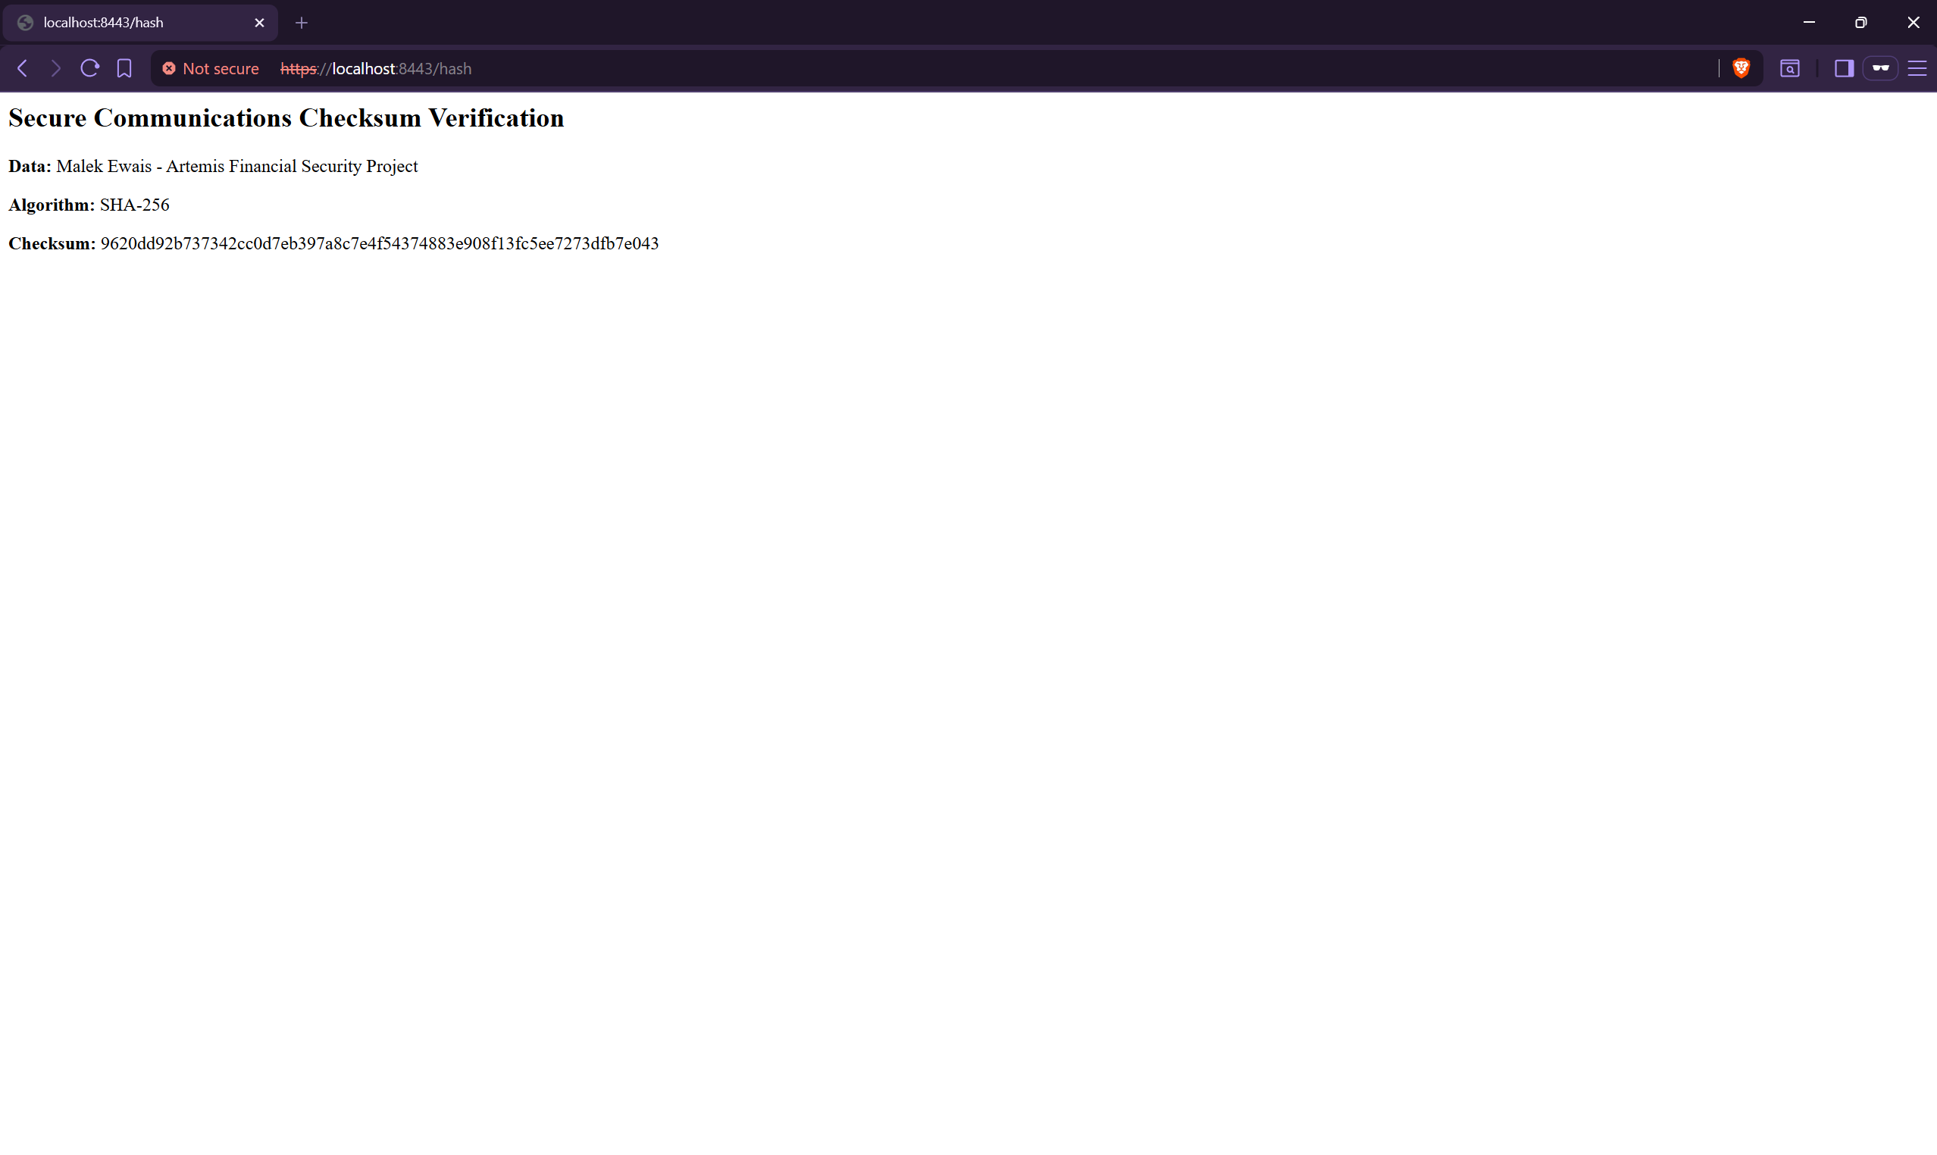

Secure Communications



Secondary Testing

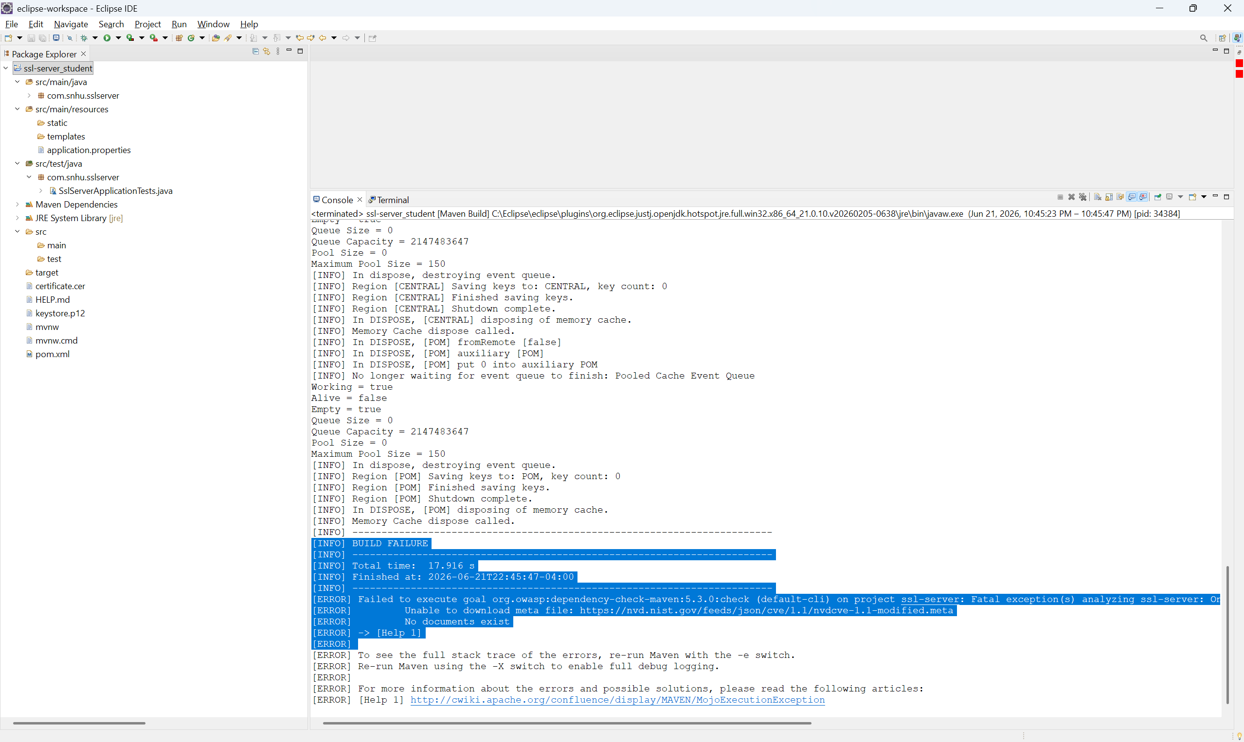

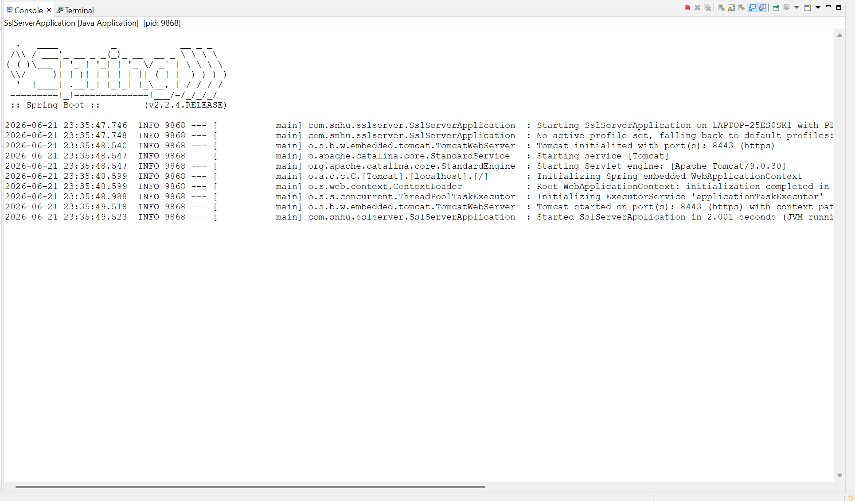

I ran the OWASP Dependency-Check tool to perform a secondary security review of the application. The scan began successfully but was unable to retrieve vulnerability data from the National Vulnerability Database (NVD), which prevented the report from completing. However, the application compiled and ran successfully after the refactoring, and no new security issues were introduced by the changes made during this project.

Functional Testing



Summary

For this project, I refactored the Artemis Financial application to improve security and support secure communications. The main changes included generating a self-signed SSL certificate, configuring the application to use HTTPS, and implementing SHA-256 checksum verification. These changes helped protect data during transmission and provided a way to verify that information was not altered.
Several areas of security were addressed during the refactoring process. HTTPS was implemented to encrypt communications between the client and server, helping protect sensitive information while it is being transmitted. SHA-256 hashing was added to generate checksum values and verify data integrity. I also generated and exported a certificate using Java Keytool to support secure communications. In addition, I performed static testing with the OWASP Dependency-Check tool and reviewed the results to identify any potential security concerns related to the application's dependencies.
I added multiple layers of security to the application rather than relying on a single solution. HTTPS protects data in transit, SHA-256 helps verify data integrity, and certificate-based security supports trusted communication. Together, these measures strengthen the application's overall security and help protect the sensitive financial information handled by Artemis Financial.

Industry Standard Best Practices

Throughout this project, I applied several industry standard security practices to maintain and improve the security of the application. I implemented HTTPS using SSL/TLS encryption to secure communications between the client and server. I also used the SHA-256 hashing algorithm to generate checksum values that can be used to verify the integrity of transmitted data. These practices help reduce the risk of data being intercepted or modified during transmission.

I also followed secure development practices by generating and using certificates, properly configuring the application for secure communications, and performing static analysis with the OWASP Dependency-Check tool. These steps helped verify that the security improvements did not introduce additional issues into the application.
Using secure coding best practices provides long-term value to the company. Financial organizations are responsible for protecting sensitive customer information, and security weaknesses can lead to data breaches, financial losses, and damage to customer trust. By implementing encryption, hashing, certificates, and security testing, the application is better protected against common threats and is more reliable for both the company and its customers.

